Other mortality forcing in Ecosim
EwE ver. 6.5.14749
Edited Nov 2017

A forcing multiplier has been added to the other mortality term of the Ecosim biomass loss equation. This allows the Ecopath base line other mortality rate to vary over time. This new functionality allows to user to simulate a die-off event by changing the base line other mortality rate.

The biomass loss is now calculated as
loss_{i} = Eatenof_{i} + (mo_{i} * MoMult_{it} * (1 - MoPred_{i} + MoPred_{i} * Ftime_{it}) + Emig_{i} + FishTime_{it}) * Biomass_{it}
i = Group
t = Time step
MoMult_{i} = The new other mortality forcing multiplier for this group at this timestep.
Eatenof_{i} = total biomass lost to predation on this group. This is the result of foraging arena biomass flows, all summed up into one number. This is the actual biomass not a rate.
mo_{i} = (1-EE) * pb (Other mortality rate in the Ecopath Mortalities rates grid)
MoPred_{i =} Fraction of other mortality sensitive to changes in feeding time Ecosim > Group info
Ftime_{it} = Feeding time predation risk modifier. Usually around 1.0 but gets set at each timestep based on the Ecosim parameters “Minimum foraging time”, Group info “Feeding time adjustment rate” and Group info “Predator effect on feeding time”. If these are all left at their default values then this will be basically 1.0. See EwE Users Manual 8.3 Group Info for an description of these parameters.
Emig_{i} = Emigration rate from Ecopath Other Production “Emig. Rate (/year)”
FishTime_{i} = F, fishing mortality rate, again all summed into one rate on this group
Biomass_{it} = biomass of this group at this timestep

Discussion
Other Mortality forcing has been implemented as a straight multiplier on mo(group) in Ecosim, rather then an Environmental Response Function that is applied to mo_{i} instead of the feeding rates. This means they fall under the “Forcing function” UI in Ecosim rather then the “Functional response”. The creation of an other mortality forcing function, from a time series of environmental data, will have to be done outside of EwE. To do this step a user will need to figure out how large of an other mortality multiplier it will take to achieve the correct mortality in response to the environmental driver. This will vary a lot depending on the base other mortality rate, which is displayed in the UI under Ecopath > Output > Mortality rates > Mortalities > + Other mortality rate (/year) and the growth rate of the group. If either the growth rate is high, or the other mortality is low, it will then the multiplier will need to be large to simulate a large die-off event.
Currently there’s no functionality in Ecosim to help the user choose a suitable other mortality multiplier for a specific event. To do this a user will need to calculate the appropriate size multiplier from the

EwE UI Implementation
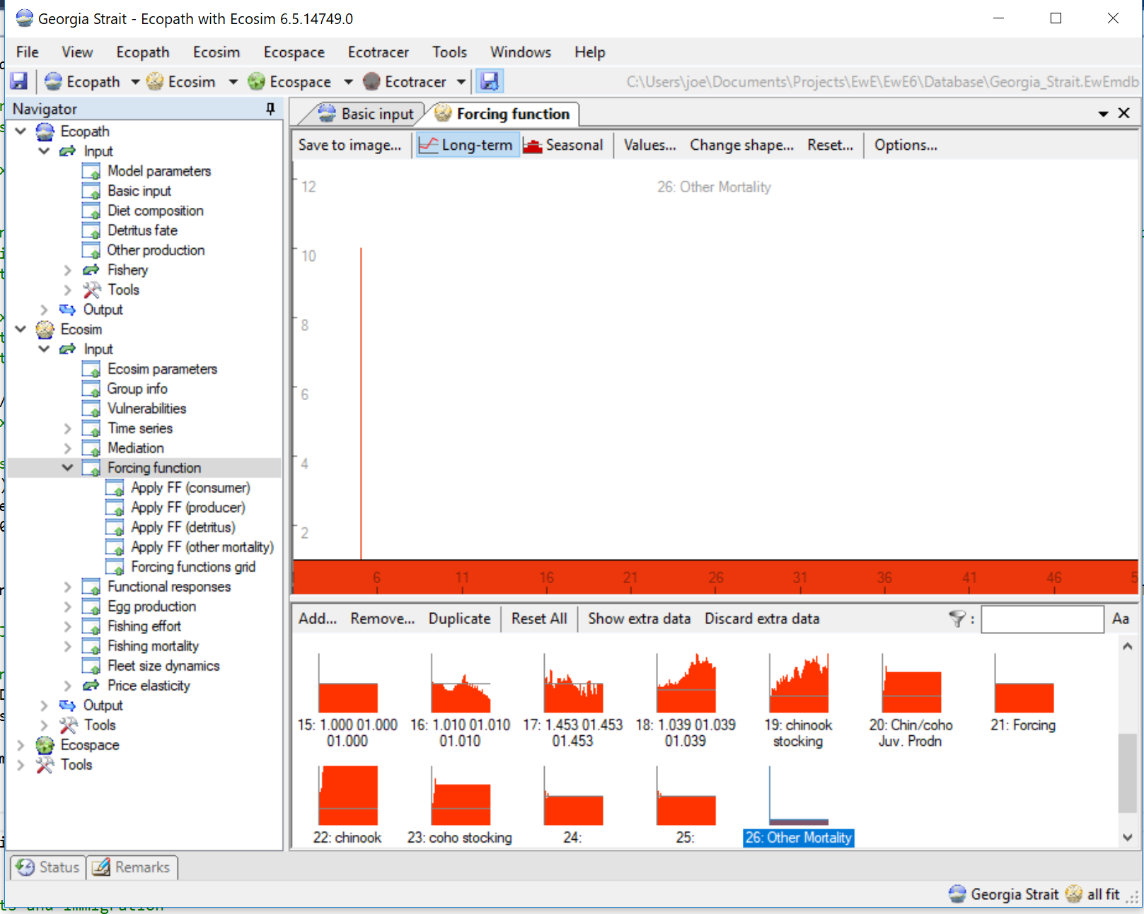
Figure 1 Forcing function UI with an “Other Mortality” forcing spike defined.

The application of Other mortality forcing functions has its own Apply FF (other mortality) UI grid.
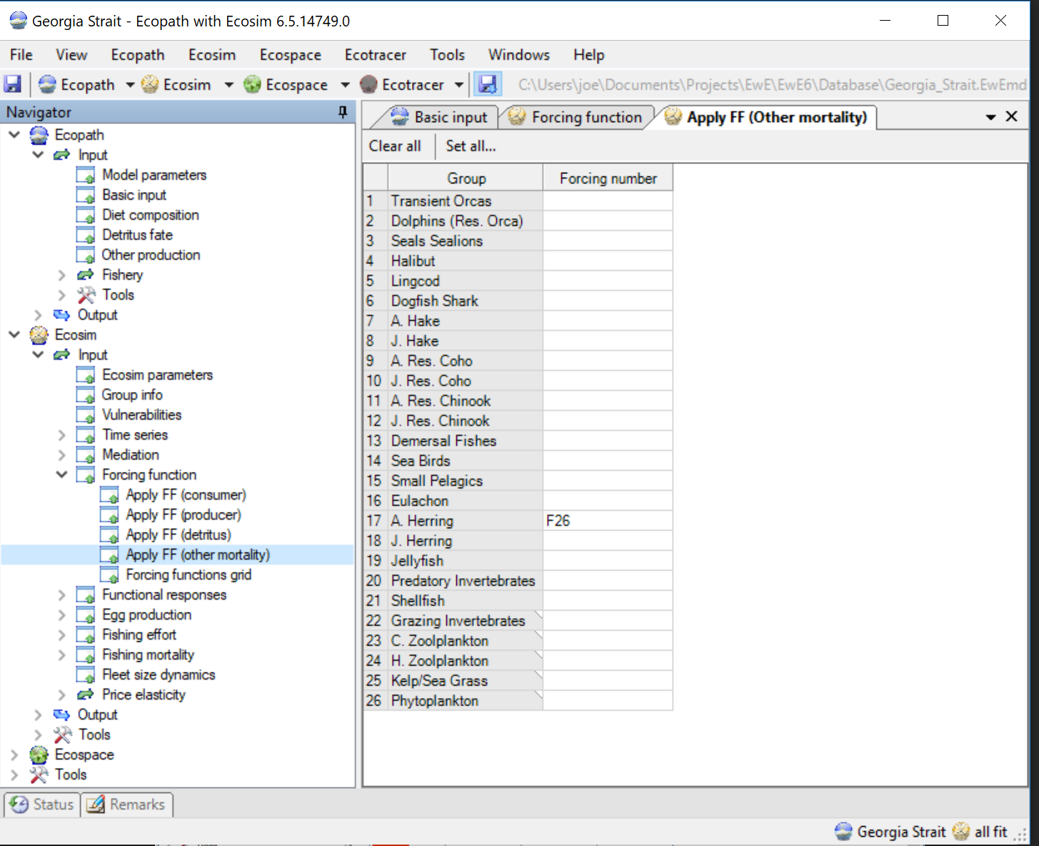
Figure 2 Application of an “Other mortality” forcing function.

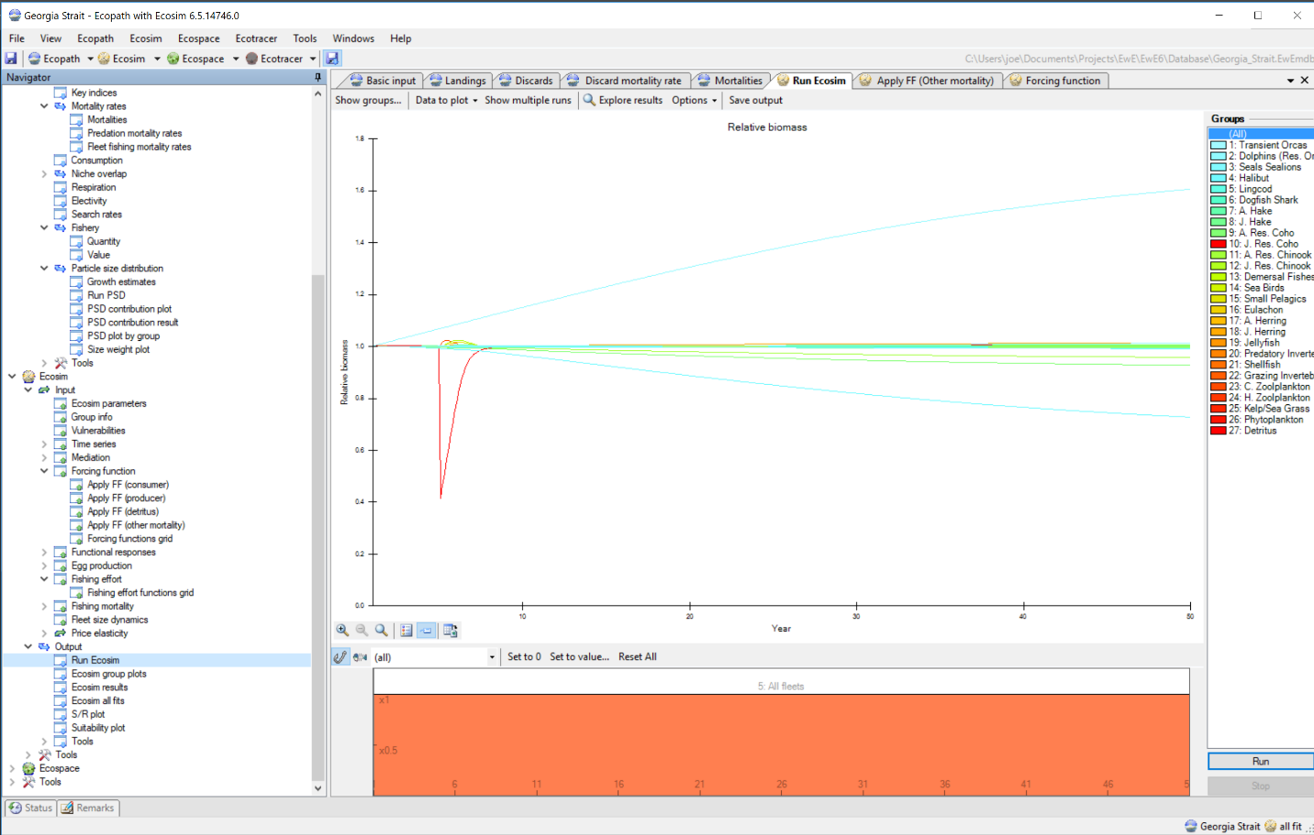
Figure 3 Ecosim run with a one-month spike “Other mortality” forcing function applied.

